**ROOFTOPS NURSERY SPRING NEWSLETTER**

**APRIL 2021**

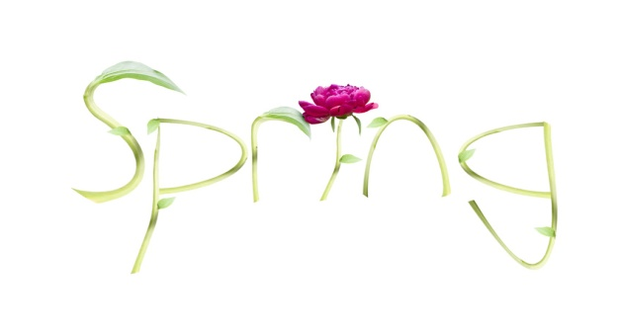

**WELCOME!**

We would like to say welcome to the Rooftops family to: **Samuel, Lenny, Cole, Teddy, Harper, Vizha, Victor, Victoria, Maria and Ariyah**



April 2021

**LEAVERS**

**Please can you let your child’s keyperson or the office know if your child has been offered a place in Nursery or Reception in September 2021, plus the name of the setting they will be moving to. Please be reminded that we require two months notice of leavers. This will enable all staff to complete the children’s profiles and leaving reports. Many thanks for your assistance in this. The notice must be two months prior to their last day at Rooftops. Please can you confirm your child's last day with your key person.**

**FAMLY**

Available on mobile and online, **Famly is the new app** used in Rooftops**.** It's GDPR-compliant and offers nurseries an all-in-one solution for communicating, learning journals, and invoicing. Your login gives you access to a personalised feed where we can update you on your child throughout the day. Access pictures, videos, observations and announcements via the newsfeed, your child’s profile, and direct messages. Stay involved in your child’s day with these real-time updates straight to your pocket. Please log in via the email link and have a look at the system and how it will enable you to share in your child’s day

**ENTRY SYSTEM**

We continue to strive to update the nursery environment as your children’s safety is paramount to us. The building is extremely secure, however, please do not allow anyone to follow you into the nursery behind you. This makes our security vulnerable.

C:\Users\Michelle Sweeney\AppData\Local\Microsoft\Windows\Temporary Internet Files\Content.IE5\KY1R6DOF\MC900356451[1].wmf

**SUN HATS AND SUN CREAM**

Please can you all provide sun cream {AT LEAST FACTOR 30} for your children. We use the outdoor space every day and the children require sun cream for these periods. We do have legionnaire sunhats at the nursery but not all of the children like to wear them, preferring their own. If this is the case, please can you provide a LABELLED sun hat for your child to stay at the nursery on their peg.

**EXTRA DAYS**

Should you require any extra days, please can you book them with Michelle or Terri. Please be advised that any days which are booked and agreed will be chargeable.

We do not allow days to be swapped or changed on a weekly basis. If the change is a permanent amendment then we will do our best, space willing, to meet that change.

**TERM TIMES**

Just a reminder about the term time dates up to the end of the Summer term.

The next half term is from Monday 1st June until Friday June 4th. Inset days are as follows: Friday 28th May and Thursday 1st July. Term time children do not attend on these days.

Summer holidays start from Friday 23rd July and the children return Wednesday 1st September.

The full term time dates schedule for September 2021 will be sent out via email at the end of July. This will give all term time dates, holidays and Inset days for 2021/2022.

**C:\Users\Michelle Sweeney\AppData\Local\Microsoft\Windows\Temporary Internet Files\Content.IE5\KY1R6DOF\MC900232518[1].wmfCHILDREN’S EATING**

Parents often come to us to discuss their children’s fussiness at mealtimes. The best way to deal with this is to be relaxed and calm and NOT react when they refuse to eat or finish their meal. Simply clear the plate away. It is best to place a small amount of all foods being offered in front of them. At nursery we do not pressurise a child to eat only encourage them to try. If you make meal times a fun and sociable experience your child is far more likely to enjoy a varied diet and mealtimes will be stress free. If you have any concerns about your child’s development, please come and speak to us and we’ll be there for you.

**WEATHER AND CLOTHING**

The warmer weather is just around the corner and will stay with us for a while WE HOPE!!! Please can you all ensure that your children have the necessary clothing on their pegs for this warm weather? Although we do have spare nursery clothes, they may not fit your child. So please can you check your child’s bag for the essential changes of clothes. Please can you also ensure that your children wears clothing that covers their shoulders especially during sunny days. Can we also state that flip flops that do not have a back strap are not suitable for all day wear, please bring in a separate pair of shoes for your children when they wear flip flops to nursery.

**THANK YOU**

We would like to thank you for choosing Rooftops for your child and look forward to a long and happy relationship with you. Should you have any queries, questions or suggestions, please let us know and we’ll do our best to rectify and address them.

RT

#### ROOFTOPS NURSERY

PRIESTLEY HOUSE,

ATHLONE STREET,

LONDON NW5 4LN

Phone 020 7267 7949

info@rooftopnursery.co.uk